**Year 2 Semester 1 (2025)**



**Faculty of Computing**

IT2120 - Probability and Statistics Lab Sheet 06

# Lab Exercise 6 (Discrete Probability Distributions)

Before starting the lab sheet, you need to create a folder in your desktop and save all your working inside the folder. Set the working directory to that folder using the following command:

setwd("paste the path of the folder")

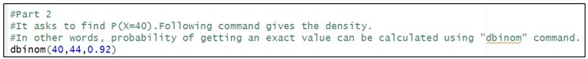**Eg:-** setwd("D:\\2025 - Sem 2\\IT2120\\Lab Sessions\\Lab 06") Use R to find the probabilities in the following questions.

1. A company claims that their drug treatment cures 92% of cases of hookworm in children. Suppose that 44 children suffering from hookworm are to be treated with this drug and that the children are regarded as a simple random sample taken from a large population of children suffering from hookworm. Let X denote the number of children cured from a sample of 44 children.
   1. What is the distribution of X?

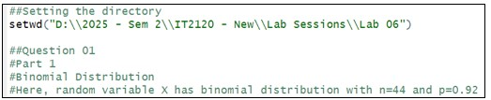

* 1. What is the probability that 40 children are cured?
  2. What is the probability that less than or equal to 35 children are cured?

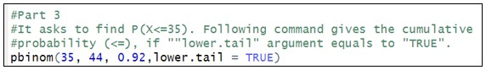

* 1. What is the probability that at least 38 children are cured?

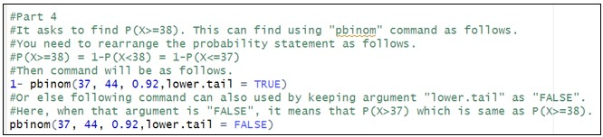

* 1. 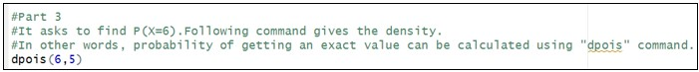What is the probability that between 40 and 42 (both inclusive) children are cured?

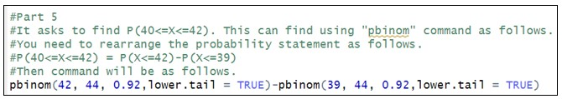

1. Data from the maternity ward in a certain hospital shows that there is a historical average of 5 babies born in this hospital every day.
   1. What is the random variable (X) in the problem?

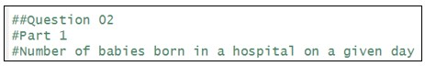

* 1. What is the distribution of X?

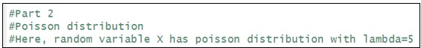

* 1. What is the probability that 6 babies will be born in this hospital tomorrow?
  2. What about the probability of more than 6 babies be born in this hospital .tomorrow?

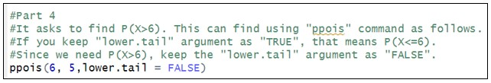

## Exercise

**Instructions:** Create a folder in your desktop with your registration number (Eg: ”IT.......”). You need to save the R script file and take screenshots of the command prompt with answers and save it in a word document inside the folder. Save both R script file and word document with your registration number (Eg: ”IT........”). After you finish the exercise, zip the folder and upload the zip file to the submission link.

1. An IT company claims that their newly developed learning platform improves student performance in online tests. According to previous data, 85% of students who used the platform passed their online tests. A batch of 50 students is selected at random who have completed the course using this platform. Let X denote the number of students who passed the test out of 50 students.
   1. What is the distribution of X?

**Answer:** Binomial Distribution. Here, random variable X has binomial distribution with n=50 and p=0.85.



* 1. ii. What is the probability that at least 47 students passed the test?

**Answer:** This asks for P(X >= 47). We rearrange this as 1 - P(X <= 46).

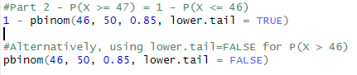

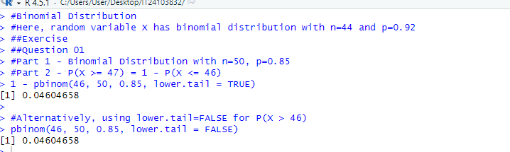

1. A call center receives an average of 12 customer calls per hour.
   1. What is the random variable (X) for the problem?

**Answer:** Number of customer calls received in the call center in a given hour.

* 1. What is the distribution of X?

**Answer:** Poisson distribution. Here, random variable X has poisson distribution with lambda=12.

iii. What is the probability that exactly 15 calls are received in an hour?

**Answer:** This asks for P(X = 15).

